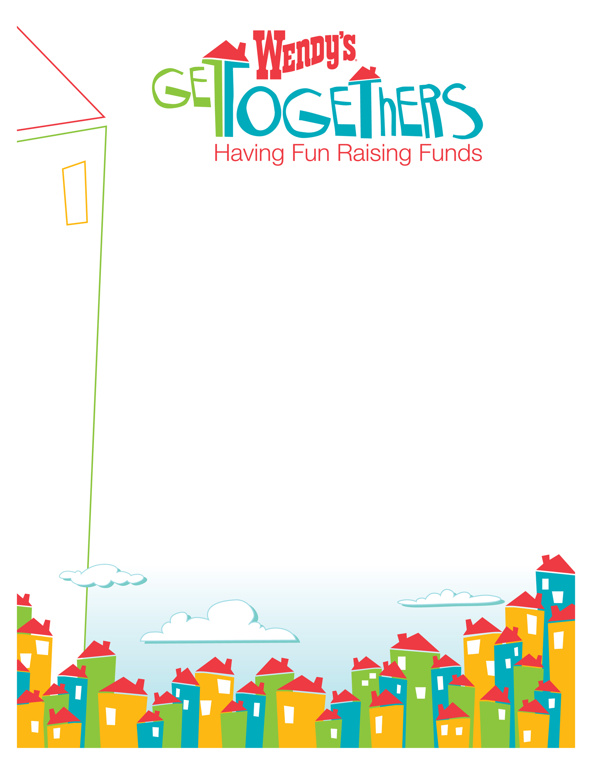
Family Night
Help us raise funds for the kids!

Saturday, September 2
4-9 PM

Wendy’s at 1234 Anystreet
Columbus, Ohio

10% of all sales will go towards
The [featured organization].

(Paste desired organization image/logo here)

